n l m_{l} m_{s}
- State the four quantum numbers and the possible values they may have.
First - Primary Quantum number (n) = size of electron cloud n = 1 up to ∞….in reality n = 1 -7
Second – Azimuthal or Angular Momentum Quantum number ((l) = shape of electron cloud;
l = 0 up to (n-1)…. When l = 0 (s cloud), 1 (p cloud), 2 (d cloud), 3 (f cloud)
Third – Magnetic Quantum number (m_{l}) = location or spatial orientation m_{l} = - l to l
Fourth – Spin Quantum number (m_{s}) = electron spin m_{s} = +1/2 or -1/2
2. Name the orbitals described by the following quantum numbers
a. n = 3, l = 0 3s c. n = 3, l = 2 3d
b. n = 3, l = 1 3p d. n = 5, l = 0 5s
3. Give the n and l values for the following orbitals
a. 1s (1,0) d. 4d (4,2)
b. 3s (3,0) e. 5f (5,3)
c. 2p (2,1)
4. Place the following orbitals in order of increasing energy:
1s, 3s, 4s, 6s, 3d, 4f, 3p, 7s, 5d, 5p 1s 3s 3p 4s 3d 5p 6s 4f 5d 7s
5. What are the possible m_{l} values for the following types of orbitals?
a. s 0 c. d -2, -1, 0, +1, +2
b. p -1, 0, +1 d. f -3, -2, -1, 0, +1, +2, +3
6. How many possible orbitals are there for n =
a. 4 16 = n² 4s 4p_{x}, 4p_{y}, 4p_{z} 4d, 4d, 4d, 4d, 4d 4f, 4f, 4f, 4f, 4f, 4f, 4f
b. 10 100
7. How many electrons can inhabit all of the n=4 orbitals?
32 = 2n² 4s² 4p_{x}², 4p_{y}², 4p_{z}² 4d², 4d², 4d², 4d², 4d² 4f², 4f², 4f², 4f², 4f², 4f², 4f²
Identify the element whose last electron would have the following four quantum numbers:

8. 3, 1, -1, +1/2____Al_______ 11. 4, 3, +3, -1/2___ Lu________
9. 4, 2, +1, +1/2___ Mo _____ 12. 2, 1, +1, -1/2____ Ne _______
10. 6, 1, 0, -1/2____ At ______
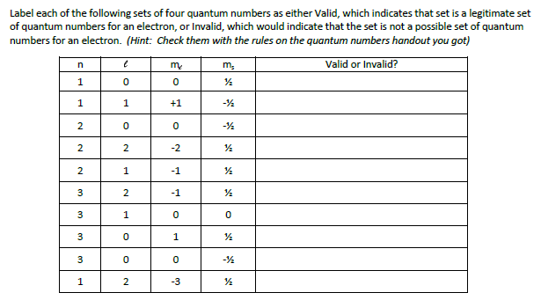
13.
VALID

INVALID

VALID

INVALID

VALID

VALID

INVALID

INVALID

VALID

INVALID

Which of the following represents a permissible set of quantum numbers? (answer “yes” if permissible and “no” if no permissible)

14. 2, 2, +1, -1/2____ NO_______ 17. 7, 0, 0, -1/2_____ YES _______
15. 5, 1, 0, +1/2_____ YES ______ 18. 4, 1, 8, +1/2______ NO_______
16. 6, 3,-2, +1/2_____ YES ______

Write the four quantum numbers which describe the location of the highest energy electron of the following:

19. N #7_____ (2, 1, 1, +1/2)_____ 22. Re #75____(5, 2, 2, +1/2)_____
20. Ni #28____(3, 2, 0, -1/2)_____ 23. Pu #94____(5, 3, 1, +1/2)_____
21. Xe #54____(5, 1, 1, -1/2)____ 24. Br #35____(4, 1, 0, -1/2)______

Give the four quantum numbers which describe the location of each of the following:

25. The 4th electron in carbon_____(2, 0, 0, -1/2)____________________________
26. The 25th electron in Hf________(3, 2, 2, +1/2)___________________________
27. The 57th electron in Ho_______(5, 2, -2, +1/2)___________________________
28. The 49th electron in Xe_______(5, 1, -1, +1/2)___________________________

